Landsat Land Surface Temperature (LST)
This analysis compares three ways to summarize Landsat land surface temperature across Austin census tracts, block groups, and hex8 cells. The goal is to select the clearest metric for future use and decide where the supporting code and data should be stored in GitHub.
A couple of things before I get into the data:
- “Landsat satellites pass over a specific point on Earth by traveling near-polar, sun-synchronous orbit . This specific orbital configuration ensures that the satellite maintains a consistent, predictable schedule for imaging the Earth's surface.”
- “Because the orbit is "sun-synchronous," the angle of the sun relative to the Earth's surface remains nearly identical during every pass. Landsat 8 and 9 (the satellites we are using) cross the equator at approximately 10:12 a.m. local time on every single pass. This provides uniform illumination, which minimizes shadows and clouds while maximizing data consistency. Since Austin is north of the equator the images we get for Austin come at around 10:15 AM and 10:45 AM.”
- On sunny summer days, land surface temperature (LST) over dry, dark, or built-up surfaces such as asphalt and concrete can exceed air temperature by 10°C to 20°C (18°F to 36°F), and sometimes more.
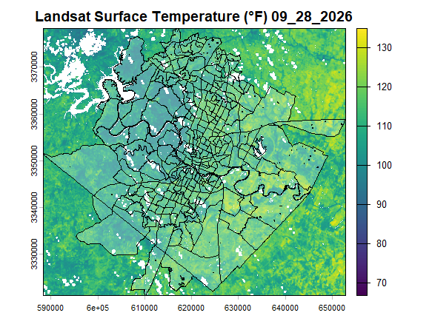
I used the R package rsi to automate the data workflow. The package downloads spatial data from Spatiotemporal Asset Catalogs (STAC), computes standard spectral indices from the Awesome Spectral Indices project, and formats the output as local raster files and bricks using terra and sf classes. My script now performs these steps directly, so the raster images do not need to be downloaded in advance. For the area covering all census tracts that intersect Austin, each image ranges from about 80 KB (when clouds obscure the scene, and no usable data are available), to 8.5 MB on relatively cloud-free days. Figure 1 shows conditions on August 28, 2026.
Figure 1 Landsat Surface Temperature

In our previous discussion, we agreed to simplify the analysis into three categories, although we have not yet selected a final metric. I therefore developed scripts to calculate the following three candidate metrics:
- The average LST over the 5-month period
- The percentile of LST over the 5-month period
- The percentage of pixels within each boundary that exceeded 120°F, a land surface temperature that corresponds approximately to an air temperature of 100°F
Maps are on the following page:

Average LST by census tract, block group, and hex8 cell
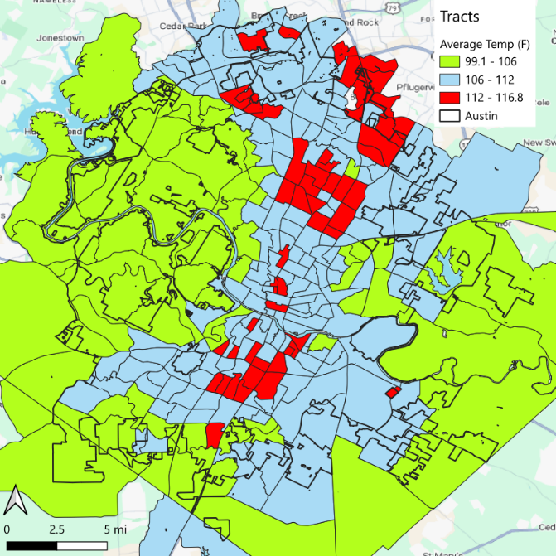  Figure 2 Average LST by census tract | 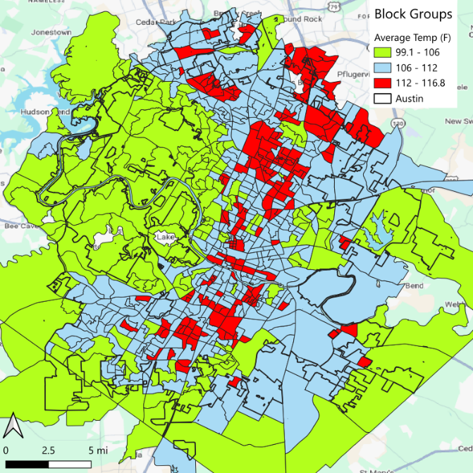  Figure 3 Average LST by census block group
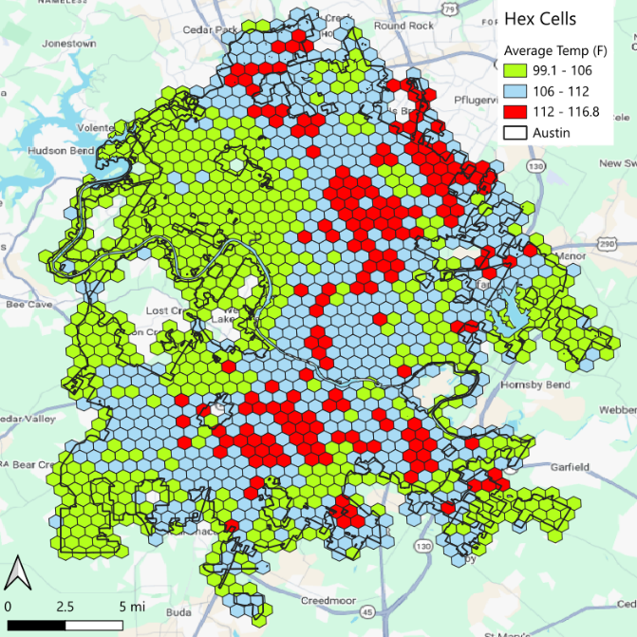
Figure 4 Average LST by Hex8 cells

Overall LST percentile by census tract, block group, and hex8 cell
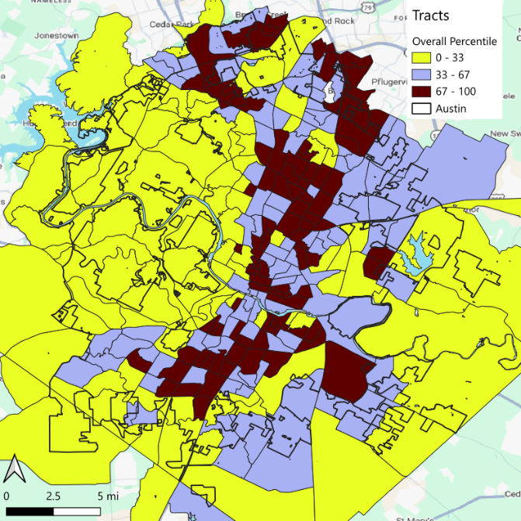  Figure 5 Overall LST by percentile, census tract | 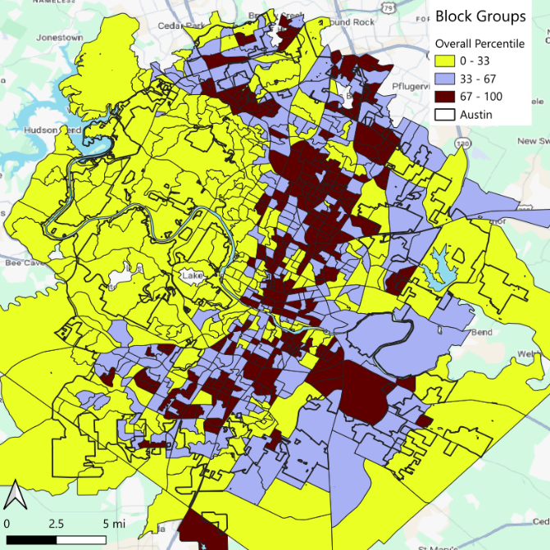  Figure 6 Overall LST by percentile, census block group
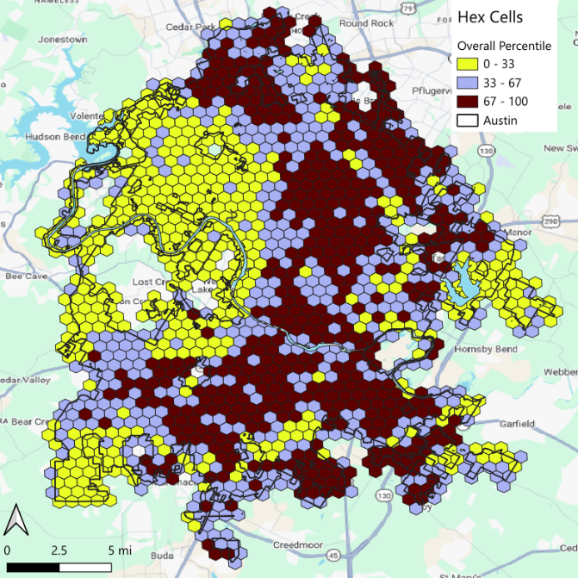
Figure 7 Overall LST by percentile, hex8 cells

Percentage of pixels exceeding 120°F by census tract, block group, and hex8 cell
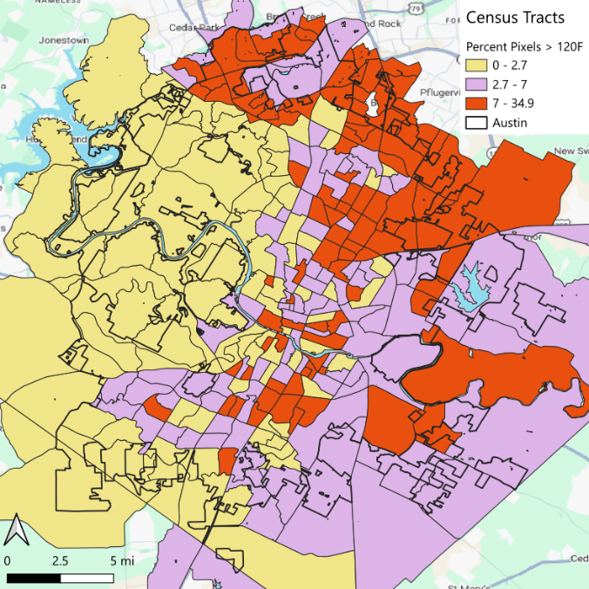  Figure 8 Percentage of pixels exceeding 120°F, census tract | 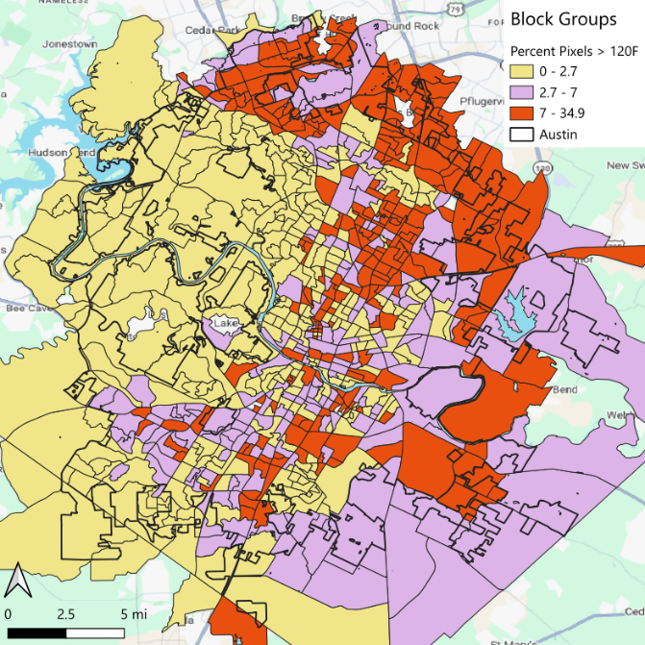  Figure 9 Percentage of pixels exceeding 120F, census block group
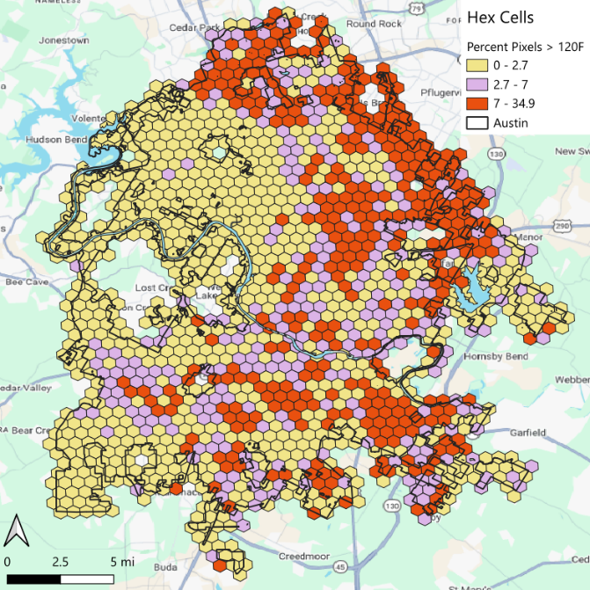
Figure 10 Percentage of pixels exceeding 120F, Hex8 cells

All scripts and outputs are available on my system. The remaining decisions are which of these three metrics to use, whether to evaluate any additional approaches, and where to store the materials in GitHub.

